**BufferedReader**.

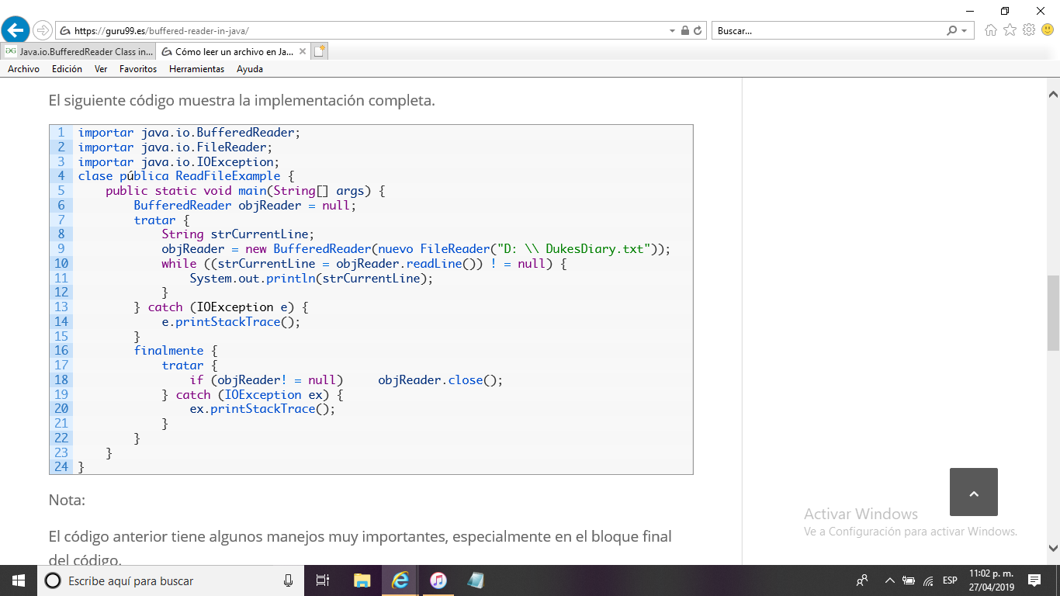

**CharArrayReader.**

char[] chars = "123".toCharArray();

CharArrayReader charArrayReader =

new CharArrayReader(chars);

int data = charArrayReader.read();

while(data != -1) {

//do something with data

data = charArrayReader.read();

}

charArrayReader.close();

**FileReader.**

Reader fileReader = new FileReader("c:\\data\\input-text.txt");

int data = fileReader.read();

while(data != -1) {

//do something with data...

doSomethingWithData(data);

data = fileReader.read();

}

fileReader.close();

**InputStreamReader.**

InputStream inputStream = new FileInputStream("c:\\data\\input.txt");

Reader inputStreamReader = new InputStreamReader(inputStream);

int data = inputStreamReader.read();

while(data != -1){

char theChar = (char) data;

data = inputStreamReader.read();

}

**PipedReader.**

inputStreamReader.close();

PipedWriter pipedWriter = new PipedWriter();

PipedReader pipedReader = new PipedReader(pipedWriter);

int data = pipedReader.read();

while(data != -1) {

//do something with data...

doSomethingWithData(data);

data = pipedReader.read();

}

pipedReader.close();

**StringReader.**

String input = "Input String... ";

StringReader stringReader = new StringReader(input);

int data = stringReader.read();

while(data != -1) {

//do something with data...

doSomethingWithData(data);

data = stringReader.read();

}

stringReader.close();

**BufferedReader.**

int bufferSize = 8 * 1024;

BufferedWriter bufferedWriter =

new BufferedWriter(

new FileWriter("c:\\data\\output-file.txt"),

bufferSize);

**CharArrayWriter.**

CharArrayWriter charArrayWriter = new CharArrayWriter();

charArrayWriter.write("CharArrayWriter");

char[] chars1 = charArrayWriter.toCharArray();

charArrayWriter.close();

**OutPutStreamReader.**

OutputStream outputStream = new FileOutputStream("c:\\data\\output.txt");

Writer outputStreamWriter = new OutputStreamWriter(outputStream);

outputStreamWriter.write("Hello World");

outputStreamWriter.close();

**PipedWriter.**

PipedWriter pipedWriter = new PipedWriter();

while(moreData()) {

int data = getMoreData();

pipedWriter.write(data);

}

pipedWriter.close();

**StringWriter.**

StringWriter stringWriter = new StringWriter();

//write characters to writer.

stringWriter.write("This is a text");

String data = stringWriter.toString();

StringBuffer dataBuffer = stringWriter.getBuffer();

stringWriter.close();

**PrintWriter**

FileWriter writer = new FileWriter("d:\\data\\report.txt");

PrintWriter printWriter = new PrintWriter(writer);

printWriter.print(true);

printWriter.print((int) 123);

printWriter.print((float) 123.456);

printWriter.printf(Locale.UK, "Text + data: %1$", 123);

printWriter.close();

**FileInputStream.**

FilterInputStream inputStream = new FilterInputStream(new FileInputStream("c:\\myfile.txt"));

**PipedInputStream.**

InputStream input = new PipedInputStream(pipedOutputStream);

int data = input.read();

while(data != -1) {

//do something with data...

doSomethingWithData(data);

data = input.read();

}

input.close();

**File InputStream.**

InputStream input = new FileInputStream("c:\\data\\input-text.txt");

int data = input.read();

while(data != -1) {

//do something with data...

doSomethingWithData(data);

data = input.read();

}

input.close();

**ByteArrayInputStream.**

byte[] bytes = ... //get byte array from somewhere.

InputStream input = new ByteArrayInputStream(bytes);

int data = input.read();

while(data != -1) {

//do something with data

data = input.read();

}

input.close();

**SecuenceImputStream.**

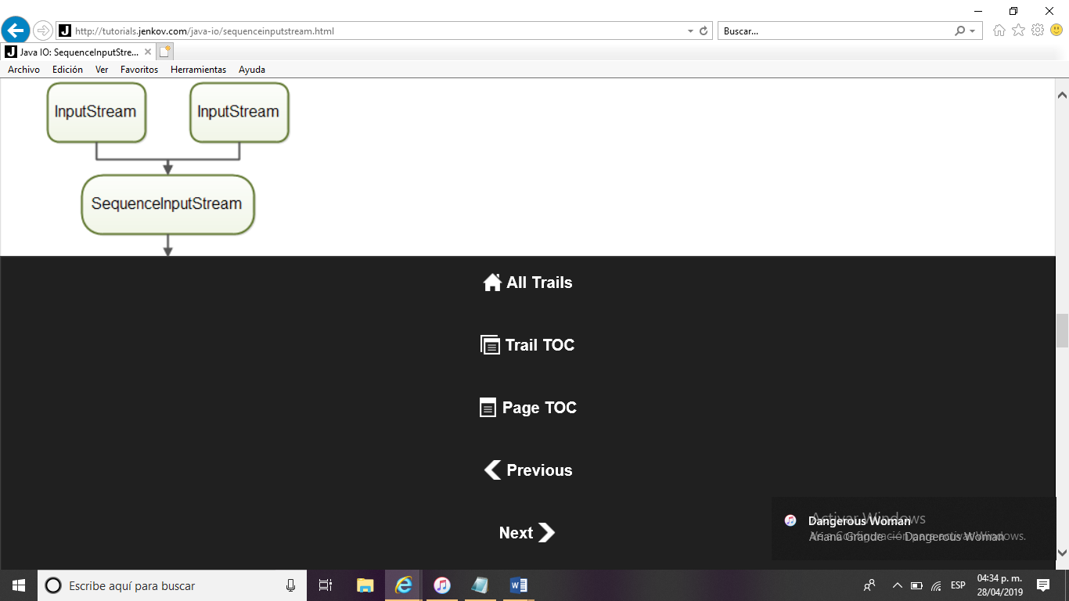

InputStream input1 = new FileInputStream("c:\\data\\file1.txt");

InputStream input2 = new FileInputStream("c:\\data\\file2.txt");

SequenceInputStream sequenceInputStream =

new SequenceInputStream(input1, input2);

int data = sequenceInputStream.read();

while(data != -1){

System.out.println(data);

data = sequenceInputStream.read();

}

**String BufferInput Stream.**

int bufferSize = 8 * 1024;

InputStream input = new BufferedInputStream(

new FileInputStream("c:\\data\\input-file.txt"),

bufferSize

);

**ObjectInputStream.**

import java.io.*;

public class ObjectInputStreamExample {

public static class Person implements Serializable {

public String name = null;

public int age = 0;

}

public static void main(String[] args) throws IOException, ClassNotFoundException {

ObjectOutputStream objectOutputStream =

new ObjectOutputStream(new FileOutputStream("data/person.bin"));

Person person = new Person();

person.name = "Jakob Jenkov";

person.age = 40;

objectOutputStream.writeObject(person);

objectOutputStream.close();

ObjectInputStream objectInputStream =

new ObjectInputStream(new FileInputStream("data/person.bin"));

Person personRead = (Person) objectInputStream.readObject();

objectInputStream.close();

System.out.println(personRead.name);

System.out.println(personRead.age);

}

}

**FileOutPutStream.**

Here is a simple FileOutputStream example:

OutputStream output = new FileOutputStream("c:\\data\\output-text.txt");

while(moreData) {

int data = getMoreData();

output.write(data);

}

output.close();

**PipedOutputStream.**

OutputStream output = new PipedOutputStream(pipedInputStream);

while(moreData) {

int data = getMoreData();

output.write(data);

}

output.close();

**ByteArrayOutputStream.**

ByteArrayOutputStream output = new ByteArrayOutputStream();

//write data to output stream

byte[] bytes = output.toByteArray();

**ObjectOutputStream.**

ObjectOutputStream objectOutputStream =

new ObjectOutputStream(new FileOutputStream("object.data"));

MyClass object = new MyClass();

output.writeObject(object);

output.close();